**BHF – Guide for Azure Automation Update Management v1.0**

Contents

[1 Purpose 3](https://myoffice.accenture.com/personal/senthil_vel_murugan_accenture_com/Documents/refer/bright/bright/Guides/BHF%20-%20Guide%20for%20Azure%20Automation%20Update%20Management%20v1.0.docx#_Toc76550032)

[2 Scope 3](https://myoffice.accenture.com/personal/senthil_vel_murugan_accenture_com/Documents/refer/bright/bright/Guides/BHF%20-%20Guide%20for%20Azure%20Automation%20Update%20Management%20v1.0.docx#_Toc76550033)

[3 Introduction to Azure Automation Update Management 3](https://myoffice.accenture.com/personal/senthil_vel_murugan_accenture_com/Documents/refer/bright/bright/Guides/BHF%20-%20Guide%20for%20Azure%20Automation%20Update%20Management%20v1.0.docx#_Toc76550034)

[4 Create Automation Account and Log Analytics Workspace 4](https://myoffice.accenture.com/personal/senthil_vel_murugan_accenture_com/Documents/refer/bright/bright/Guides/BHF%20-%20Guide%20for%20Azure%20Automation%20Update%20Management%20v1.0.docx#_Toc76550035)

[5 Add Virtual Machines to Automation Account 5](https://myoffice.accenture.com/personal/senthil_vel_murugan_accenture_com/Documents/refer/bright/bright/Guides/BHF%20-%20Guide%20for%20Azure%20Automation%20Update%20Management%20v1.0.docx#_Toc76550036)

[6 Plan Deployment Target 8](https://myoffice.accenture.com/personal/senthil_vel_murugan_accenture_com/Documents/refer/bright/bright/Guides/BHF%20-%20Guide%20for%20Azure%20Automation%20Update%20Management%20v1.0.docx#_Toc76550037)

[7 Schedule the Update 11](https://myoffice.accenture.com/personal/senthil_vel_murugan_accenture_com/Documents/refer/bright/bright/Guides/BHF%20-%20Guide%20for%20Azure%20Automation%20Update%20Management%20v1.0.docx#_Toc76550038)

[8 Check Deployment Status 12](https://myoffice.accenture.com/personal/senthil_vel_murugan_accenture_com/Documents/refer/bright/bright/Guides/BHF%20-%20Guide%20for%20Azure%20Automation%20Update%20Management%20v1.0.docx#_Toc76550039)

[9 Troubleshoot 13](https://myoffice.accenture.com/personal/senthil_vel_murugan_accenture_com/Documents/refer/bright/bright/Guides/BHF%20-%20Guide%20for%20Azure%20Automation%20Update%20Management%20v1.0.docx#_Toc76550040)

[10 Revision History 14](https://myoffice.accenture.com/personal/senthil_vel_murugan_accenture_com/Documents/refer/bright/bright/Guides/BHF%20-%20Guide%20for%20Azure%20Automation%20Update%20Management%20v1.0.docx#_Toc76550041)

1 Purpose

The purpose of this document is to introduce the service: Azure Automation Update Management to the audience and list out the steps to onboard the infrastructure Virtual Machines (VMs) within Azure to this service. This document will serve as a guide for the BHF IO support team to perform their maintenance activity involving updating patches of OS (Operating System)

2 Scope

The scope of this document is only limited to the Virtual Machines (VMs) within Azure under the BHF SAP subscription. For any future projects under different subscriptions, the BHF IO teams can use this only as a reference.

In Scope

* Microsoft Windows Server 2016

Out of Scope

Servers running Linux flavours as below will be patched manually.

* Suse Linux Enterprise Server for SAP 12SP4
* RedHat Enterprise Server 7.8

3 Introduction to Azure Automation Update Management

Update Management in Azure Automation is used to manage operating system updates for your Windows and Linux virtual machines in Azure. You can quickly assess the status of available updates and manage the process of installing required updates for your machines reporting to Update Management. Before deploying Update Management and enabling your machines for management, make sure that you understand the information in the following sections.

Update Management integrates with Azure Monitor Logs to store update assessments and update deployment results as log data, from assigned Azure and non-Azure machines. To collect this data, the Automation Account and Log Analytics workspace are linked together, and the Log Analytics agent for Windows and Linux is required on the machine and configured to report to this workspace. Update Management supports collecting information about system updates from agents in a System Center Operations Manager management group connected to the workspace. Having a machine registered for Update Management in more than one Log Analytics workspace (also referred to as multihoming) isn't supported.

The following diagram illustrates how Update Management assesses and applies security updates to all connected Windows Server and Linux servers.

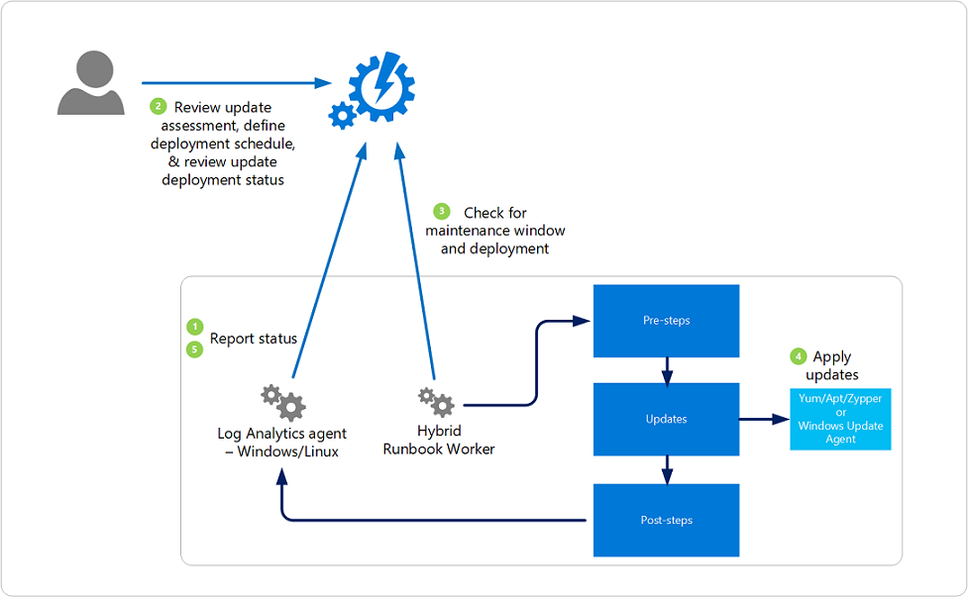

4 Create Automation Account and Log Analytics Workspace

The Log Analytics agent for Windows is required to support Update Management. The agent is used for both data collection, and the Automation system Hybrid Runbook Worker role to support Update Management runbooks used to manage the assessment and update deployments on the machine.

On Azure VMs, if the Log Analytics agent isn't already installed, when you enable Update Management for the VM it is automatically installed using the Log Analytics VM extension. The agent is configured to report to the Log Analytics workspace linked to the Automation account Update Management is enabled in.

Having a machine registered for Update Management in more than one Log Analytics workspace (also referred to as multihoming) isn't supported. BHF subscription has the below services created.

**Log Analytics Workspaces:**

* sap-law-use2-pr
* sap-law-cus-qa

**Automation accounts:**

* sap-aa-use2-pr
* sap-aa-cus-qa

From the Automation Account, go to “Update Management”. When setting up for the first time, linkage of the Log Analytics Workspace is mandatory. The link can be done as below.

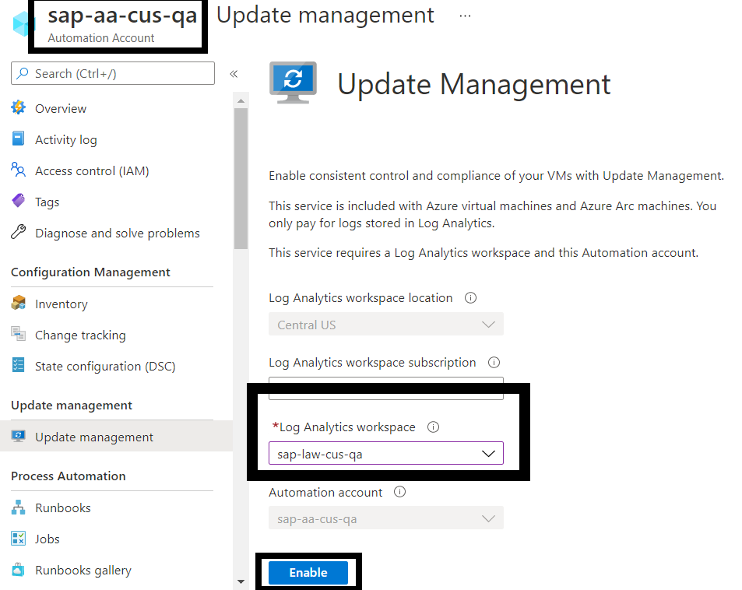

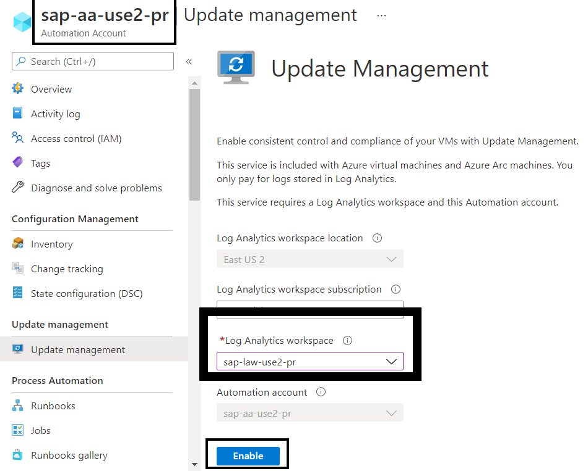

The linked Log Analytics Workspace with their respective Automation accounts are shown below.

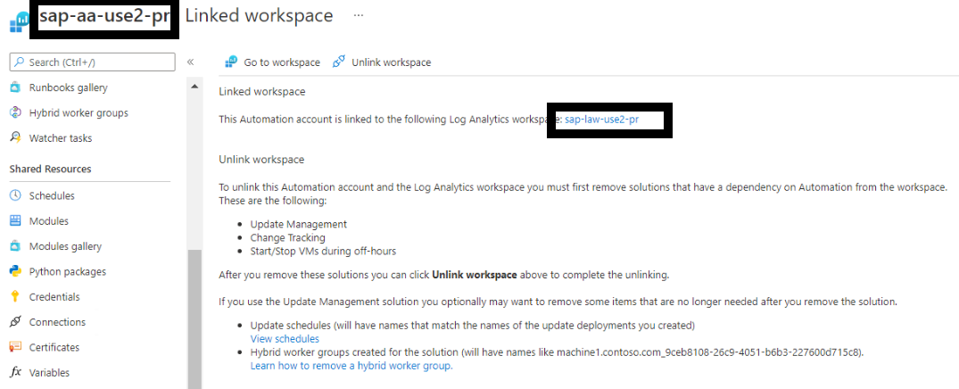

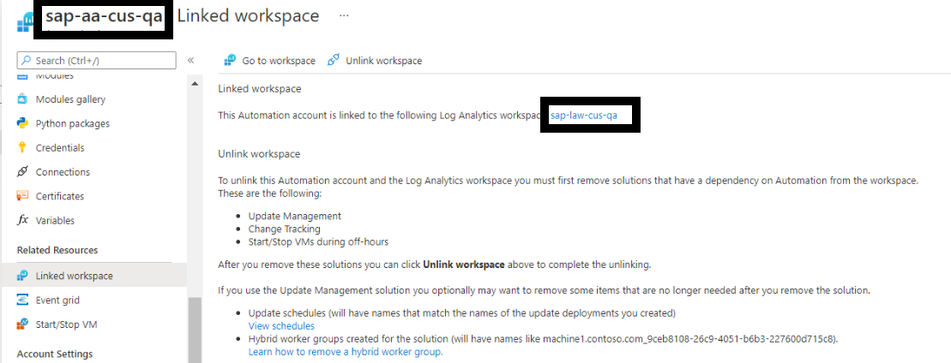

5 Add Virtual Machines to Automation Account

With the automation account and the log analytics workspace created and linked to our needs, the steps to add Virtual Machines to the automation account is described below.

Select the automation account created and go to “Update Management”

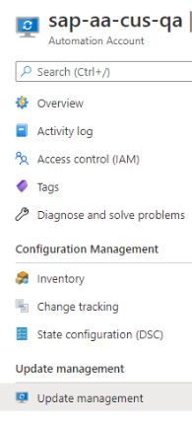

The automation account is empty. Proceed by adding the desired VMs to be part of this automation.

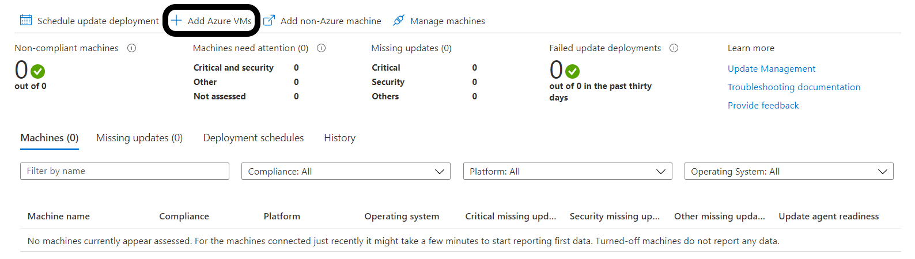

Choose the right resource group and location that is to be automated for the monthly patches and updates. The list of VMs can be further filtered by the checkbox to narrow down to the destined list. Enabling the VMs here will be installed with the Log Analytics agent, upon which the VMs will send logs and metadata to the workspace.

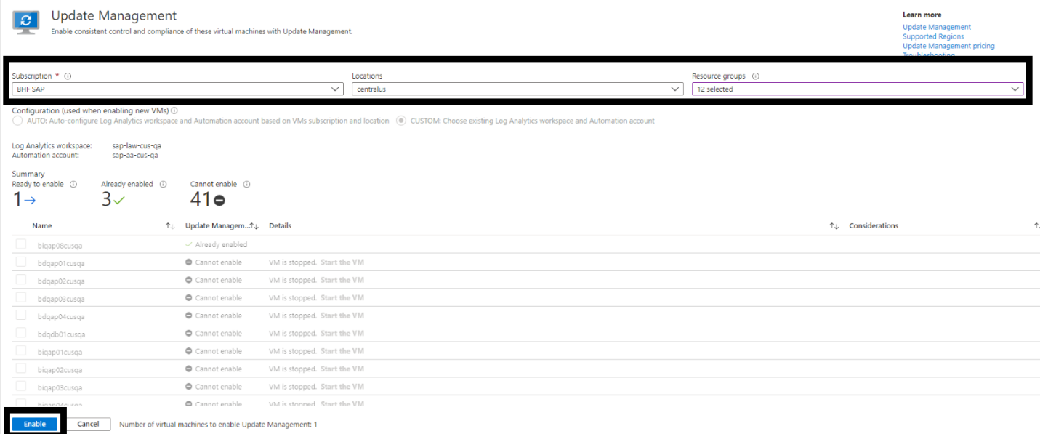

For the machines connected just recently it might take a few minutes to start reporting first data. Turned-off machines do not report any data

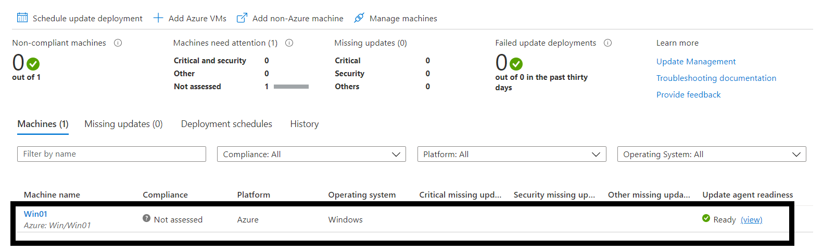

This data will be used by the automation account for the status of the VMs and its updates. Enabling VMs will take few moments. Once the agent is installed, the VMs will reflect both in the Automation account as well as the Log Analytics workspace as below.

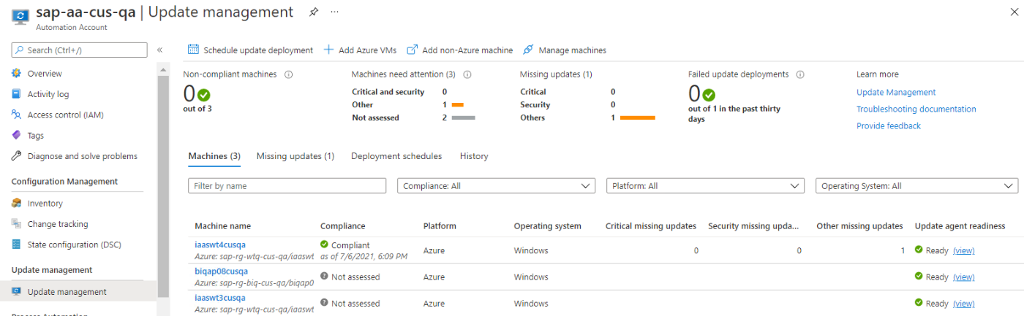

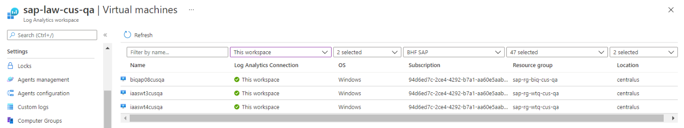

6 Plan Deployment Target

Update Management allows you to target updates to a dynamic group representing Azure or non-Azure machines, so you can ensure that specific machines always get the right updates at the most convenient times. A dynamic group is resolved at deployment time and is based on the following criteria:

* Subscription
* Resource groups
* Locations
* Tags

Alternatively, updates can be managed only for a selected Azure VM. Update deployments scoped to the specific machine are visible from both the machine and from the Automation account in Update Management Deployment schedules option.

From the Update Management screen, select “Schedule update deployment”. Choose a deployment name and select the appropriate options that follow.

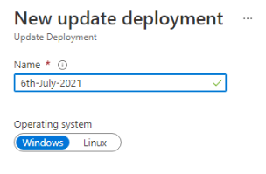

Multiple subscriptions and Resource groups can be chosen here. Locations and Tags are other filters available for selection. VMs from this entire selection will be considered but the target VM selection is possible from the following options.

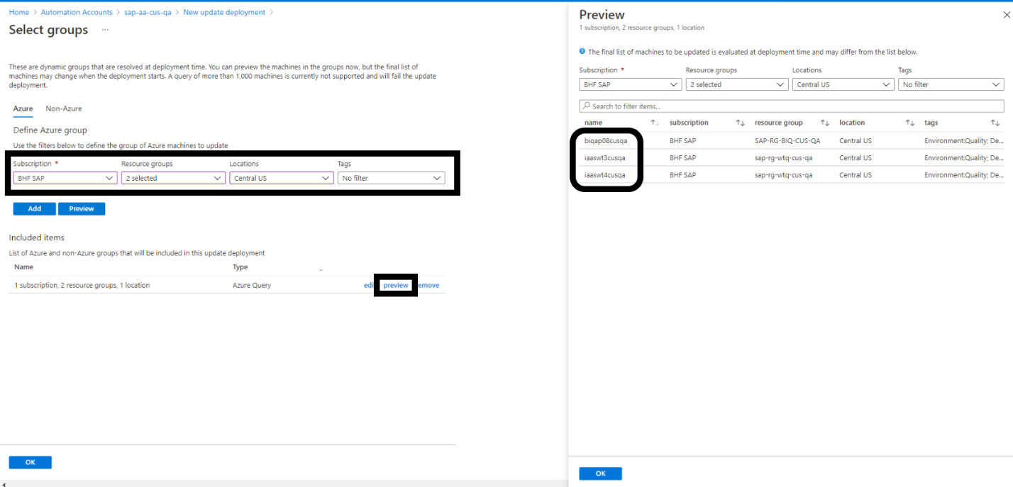

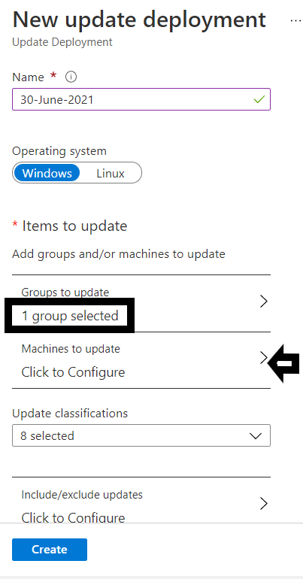

Choose the “Type” as “Machines” which will list the entire inventory from the group selection in the previous step. Individual VMs can be selected and added to the target list as below.

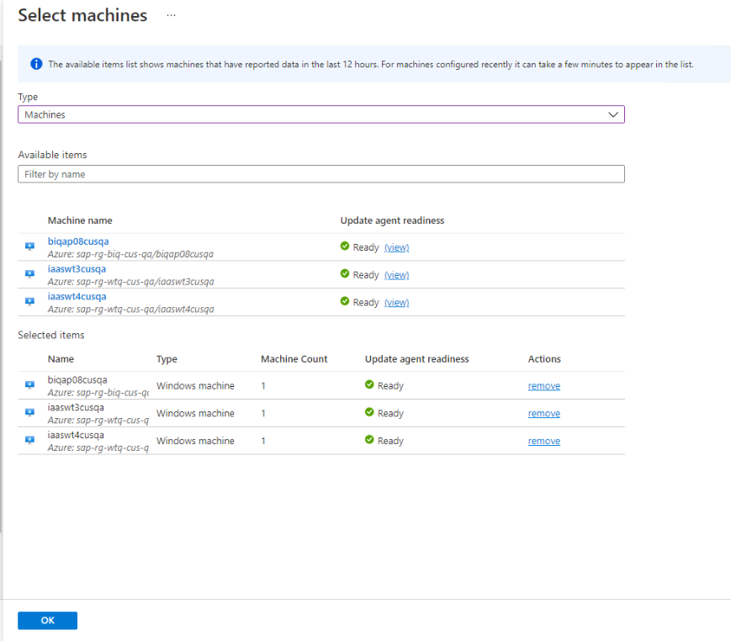

You can choose the update types to include in the deployment. For example, you can include critical or security updates, and exclude update rollups. Target updates shall be selected from the drop-down menu available in the deployment. Manual definition of updates/KBs can also be explicitly called out in the following options. Similarly updates/patches/KBs can be explicitly excluded too.

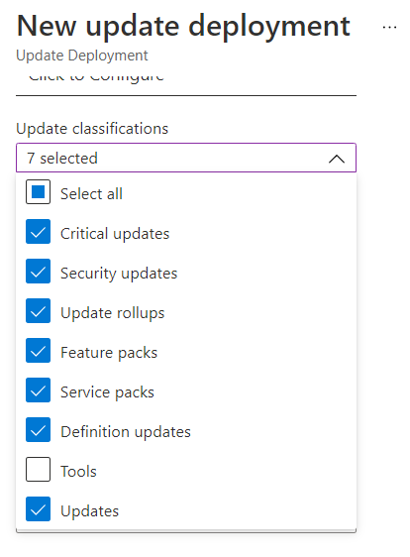

7 Schedule the Update

Scheduling an update deployment creates a schedule resource linked to the Patch-MicrosoftOMSComputers runbook that handles the update deployment on the target machine or machines. You must schedule a deployment that follows your release schedule and service window to install updates.

Every time zone selection is possible for client and support team requirements. Maintenance windows selection as well as reboot behavior can be defined from the below options. Use the Reboot options field to specify the way to handle reboots during deployment. The following options are available:

* Reboot if necessary (default)
* Always reboot
* Never reboot
* Only reboot; this option doesn't install updates

The illustration is as below.

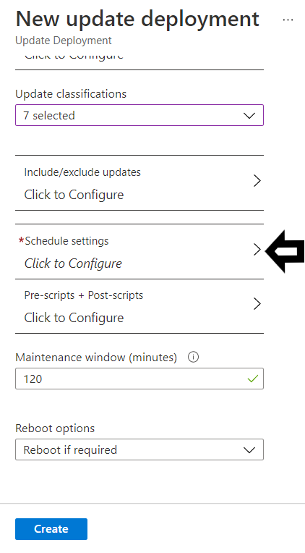 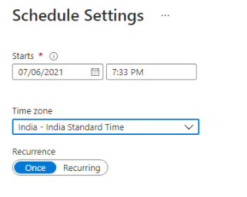

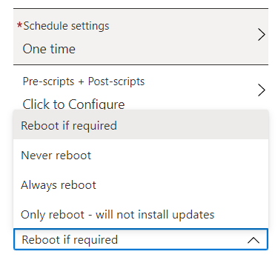

8 Check Deployment Status

After your scheduled deployment starts, you can see its status on the History tab under Update management. The status is In progress when the deployment is currently running. When the deployment ends successfully, the status changes to Succeeded. If there are failures with one or more updates in the deployment, the status is Failed.

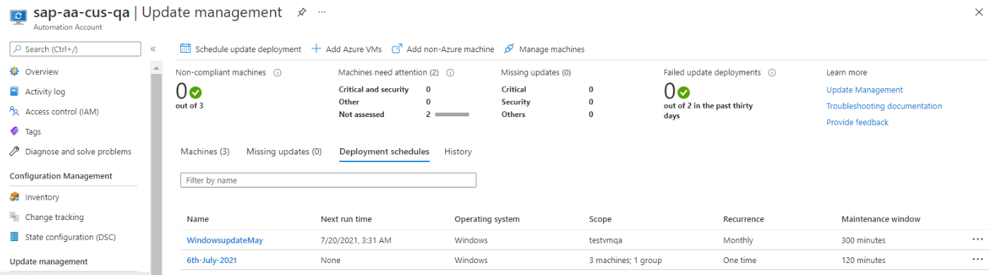

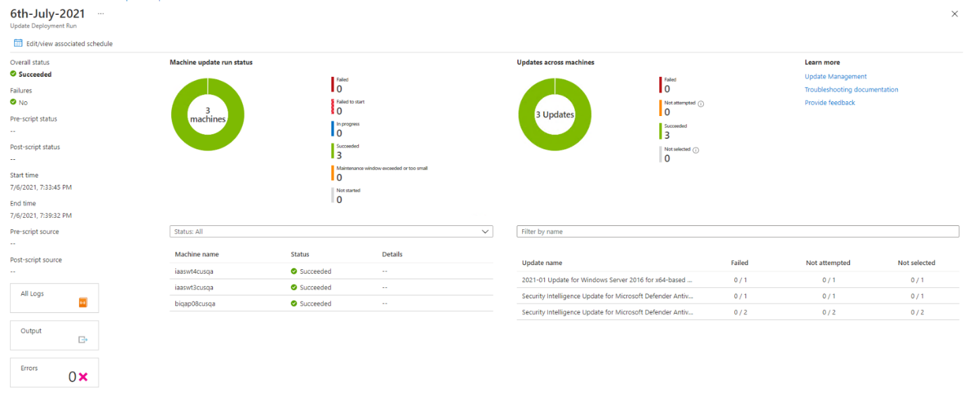

Under Update results, a summary provides the total number of updates and deployment results on the target VMs. The table on the right shows a detailed breakdown of the updates and the installation results for each.

The available values are:

**Not attempted** - The update wasn't installed because there was insufficient time available, based on the defined maintenance window duration.

**Not selected** - The update wasn't selected for deployment.

**Succeeded** - The update succeeded.

**Failed** - The update failed.

9 Troubleshoot

Microsoft troubleshooting guide for [Azure Update Management](https://docs.microsoft.com/en-us/azure/automation/troubleshoot/update-management) can be utilized for any unforeseen errors or issues.

Also refer [Azure Automation Update Management](https://docs.microsoft.com/en-us/azure/automation/update-management/overview) for the full Microsoft article.

10 Revision History

|  |  |  |  |  |
| --- | --- | --- | --- | --- |
| **Version** | **Date** | **Author** | **Approvers** | **Changes** |
| **0.1** | 6/30/2021 | Senthil Vel Murugan |  | Initial Draft |
| **1.0** | 7/6/2021 | Senthil Vel Murugan | Sasikumar Sampath | Screenshots updated to reflect BHF subscription. |
|  |  |  |  |  |
|  |  |  |  |  |
|  |  |  |  |  |
|  |  |  |  |  |